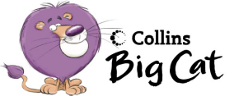

Write a Poem A

Read pages 12 and 13.

Discuss some other things that are impossible with your group. Make a list.

Using this list select some of the impossible things and write a poem of your own in the same way that Michael Rosen did.

Write your finished poem on a piece of A4 paper. Remember to give your poem a title, include a suitable illustration and don’t forget your name at the end.

Display your poems for others to read and enjoy.

White I Never Know How Poems Start Hunter Primary

Write a Poem A

Read pages 12 and 13.

Discuss some other things that are impossible with your group. Make a list.

Using this list select some of the impossible things and write a poem of your own in the same way that Michael Rosen did.

Write your finished poem on a piece of A4 paper. Remember to give your poem a title, include a suitable illustration and don’t forget your name at the end.

Display your poems for others to read and enjoy.

White I Never Know How Poems Start Hunter Primary

